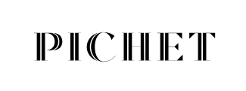

Negroni – €15
Tanqueray Gin, Campari, Carpano Antica Formula
13

Hugo - €13
Elderflower Liqueur, Prosecco, Soda Water
13

Aperol Spritz - €13
Aperol, Prosecco, Soda Water
13

Old Fashioned - €15
Wild Turkey Bourbon Whiskey, Angostura Bitter, Stout Reduction, Sugar Syrup
1A

Prosecco Royal - €13
Prosecco, Crème de Cassis
13

Expresso Martini - €14
Ketel One Vodka, Kahlua Coffee Liqueur, Sugar Syrup, Fresh Coffee

Rum Punch - €15
Pineapple Infused Rum, Cachaca, Lime, Sugar Syrup, Bitters

Allergens
1. Cereals Containing Gluten, 1A. Barley, 2. Peanuts, 3. Nuts, 4. Milk, 5. Crustaceans, 6. Molluscs, 7. Eggs,
8. Fish, 9. Celery, 10. Soy, 11. Sesame Seeds, 12. Mustard, 13. Sulphur Dioxide & Sulphites, 14. Lupin

